Project documentation on To Supply Leftover Food to Poor

**Salesforce Developer Account Creation**

Creating Developer Account:

A Salesforce developer account was created through Salesforce's official website, providing full access to features like object customization, flows, reports, and dashboards.

Account Activation:

After registration, the account was activated via email verification. Access to the Salesforce developer environment allowed configuration of objects, tabs, and other components necessary for the project.

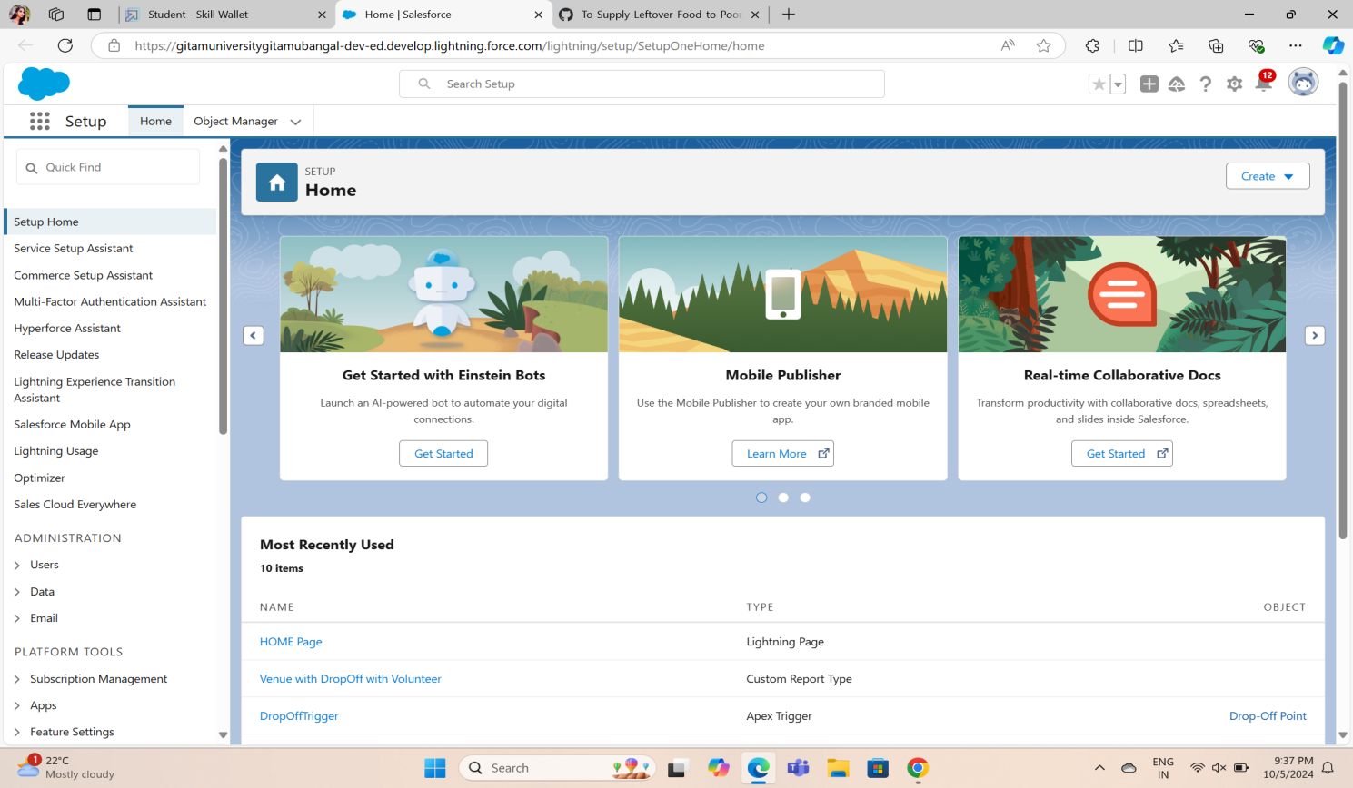

**Object Creation**

Venue Object:

The Venue Object was created to store details about locations where leftover food is collected, such as restaurants and event venues. Key fields include venue name, address, contact information, and available food quantity.

Drop-Off Point Object:

This object tracks the points where food will be delivered for distribution. Fields include drop-off location, contact person, and available storage capacity.

Task Object:

The Task Object manages tasks related to food collection and distribution, including scheduling pickups, notifying volunteers, and recording task status (completed or pending).

Volunteer Object:

Created to manage volunteer details, this object stores personal information, assigned tasks, and availability status of volunteers helping with food collection and distribution.

Execution Details Object:

This object tracks the details of food supply execution, including the date and time of food collection, the assigned volunteer, and the drop-off point where the food was delivered.

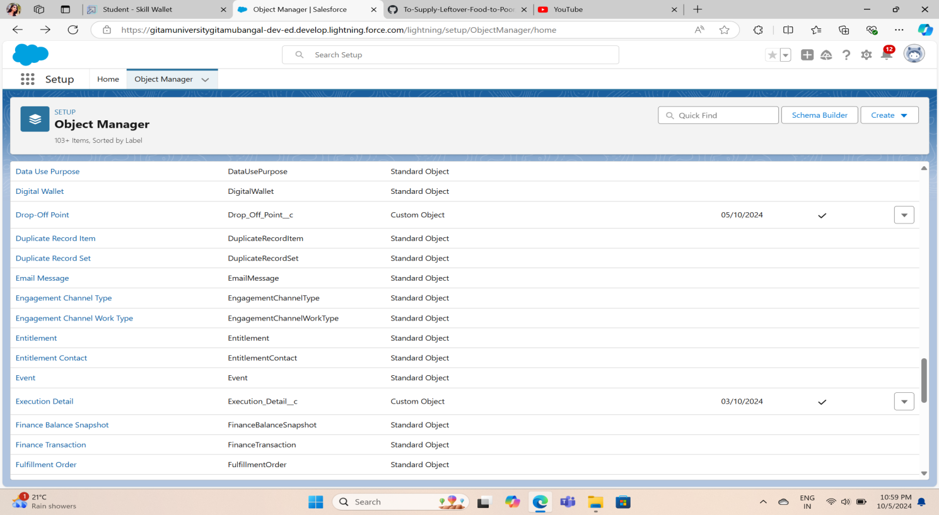

**Tabs**

Creating Custom Tab:

A custom tab for each of the created objects (Venue, Drop-Off Point, Task, Volunteer, and Execution Details) was developed. These tabs allow users to access and manage the corresponding records from the Salesforce interface.

Creating Remaining Tabs:

Additional custom tabs were created for reporting and dashboard features to ensure users have quick access to relevant insights.

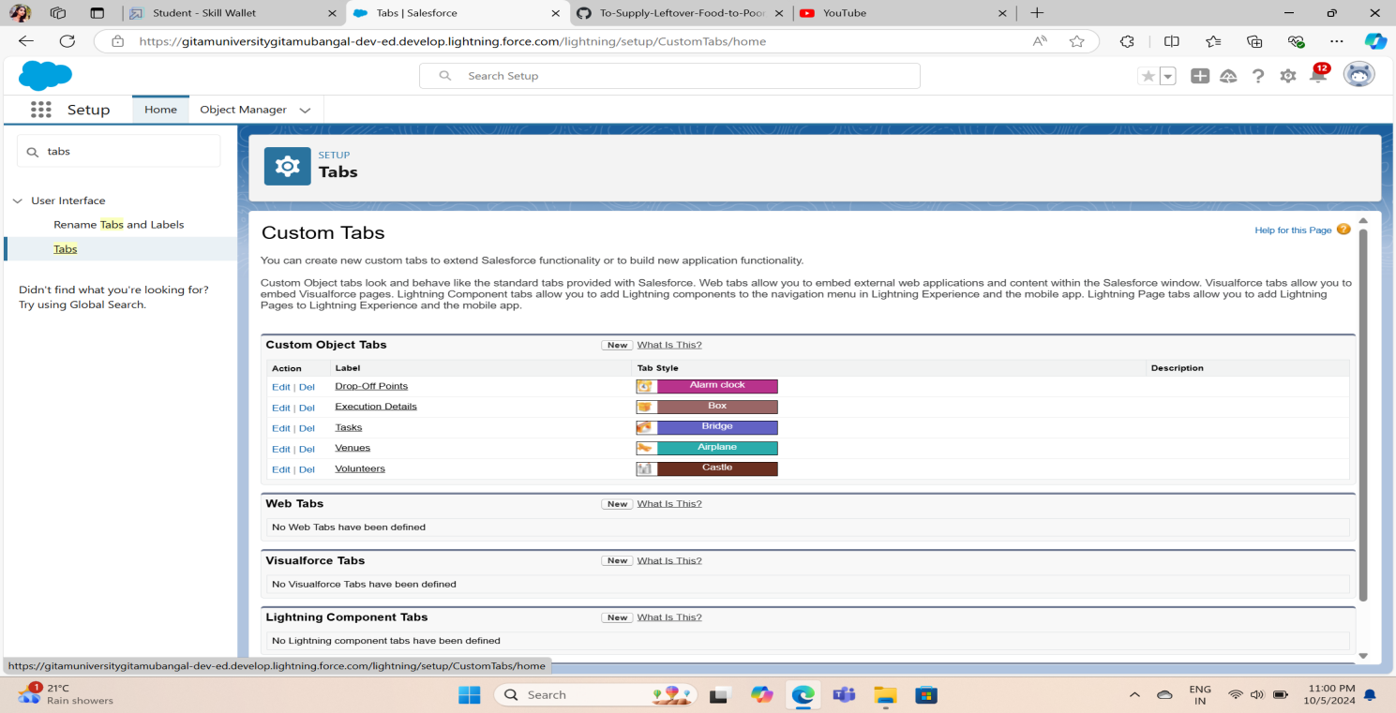

**The Lightning App**

Create a Lightning App:

A Lightning App was created to provide a streamlined interface for managing the entire food donation and distribution process. The app consolidates all objects, tabs, and reporting features, improving the overall user experience.

Field Creation

Creation of Relationship Fields in Objects:

Relationship fields were created to link Venue, Drop-Off Point, and Volunteer objects with tasks and execution details, ensuring seamless data flow across the platform.

Creation of Fields for Venue Object:

Custom fields like Venue Name, Location, Capacity, and Food Type were added to the Venue object.

Creation of Fields for Drop-Off Point Object:

Fields like Drop-Off Name, Location, Storage Capacity, and Operating Hours were created for this object.

Creation of Fields for Task Object:

Fields for Task Description, Assigned Volunteer, Due Date, and Completion Status were created.

Creation of Fields for Volunteer Object:

Volunteer details were captured using fields like Name, Availability, Skills, and Assigned Task.

Creation of Fields for Execution Details Object:

Fields such as Execution Date, Volunteer Name, Drop-Off Point, and Status were added to track operational efficiency.

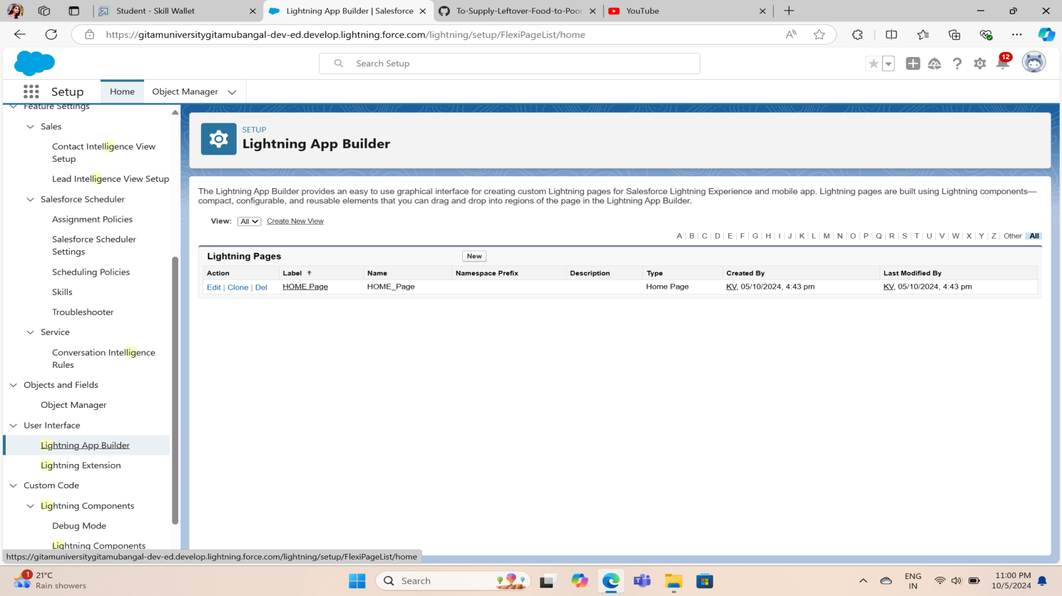

**Flows**

Create Flow to Create a Record in Venue Object:

A Salesforce Flow was created to automate the process of recording a new food collection site in the Venue object. The flow prompts users for details like venue name, location, and food availability, reducing manual entry.

**Trigger**

Create a Trigger:

A Trigger was developed to automatically create a task when a new venue record is added. This ensures that volunteers are immediately assigned to collect food from new venues.

Trigger Code:The trigger was written in Apex to automate task creation and notification whenever a venue record is created or updated. The code ensures seamless task assignment and real-time tracking.

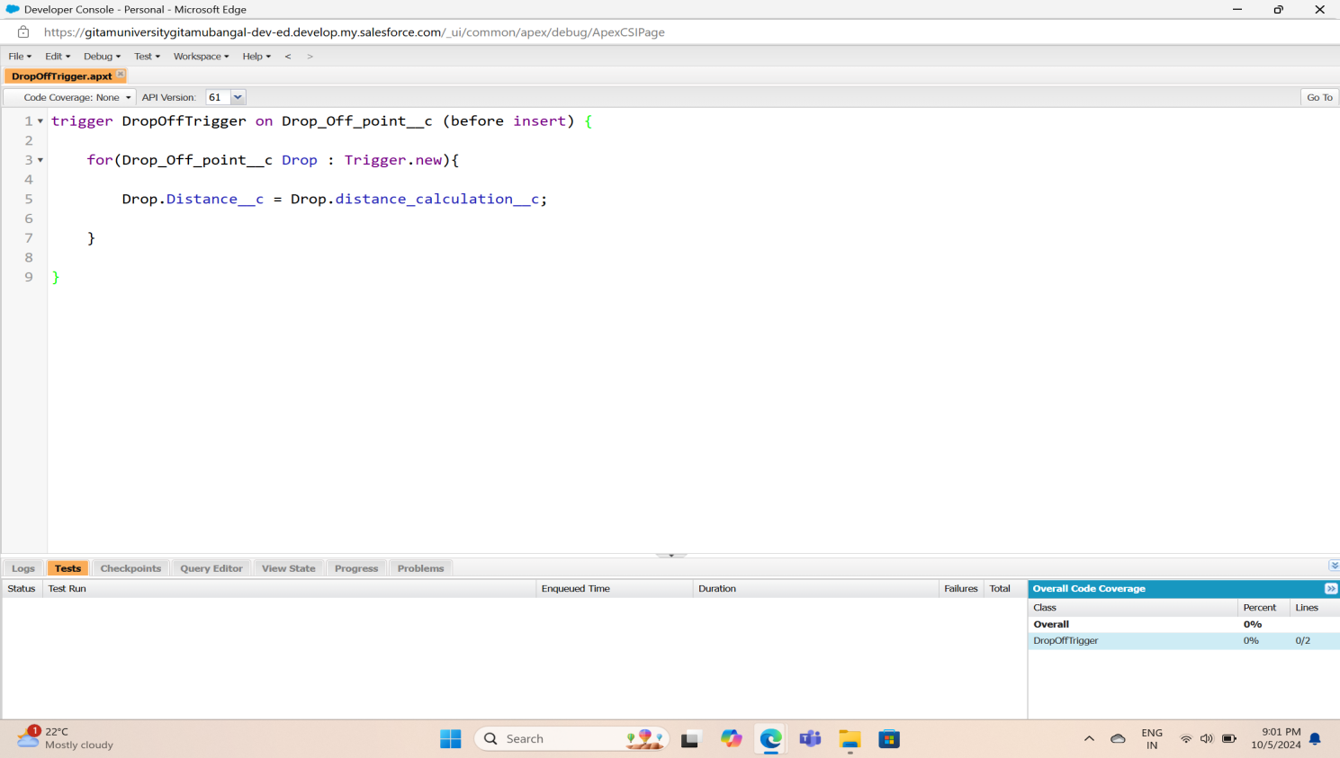

**Profiles**

**Creation of Users:**

Multiple user profiles were created to differentiate roles such as administrators, volunteers, and venue managers.

Creation of User 1: Admin user with full access to objects, reports, and dashboards.

Creation of User 2 & User 3: Volunteer users with access to specific objects (e.g., Task and Execution Details) and limited administrative rights.

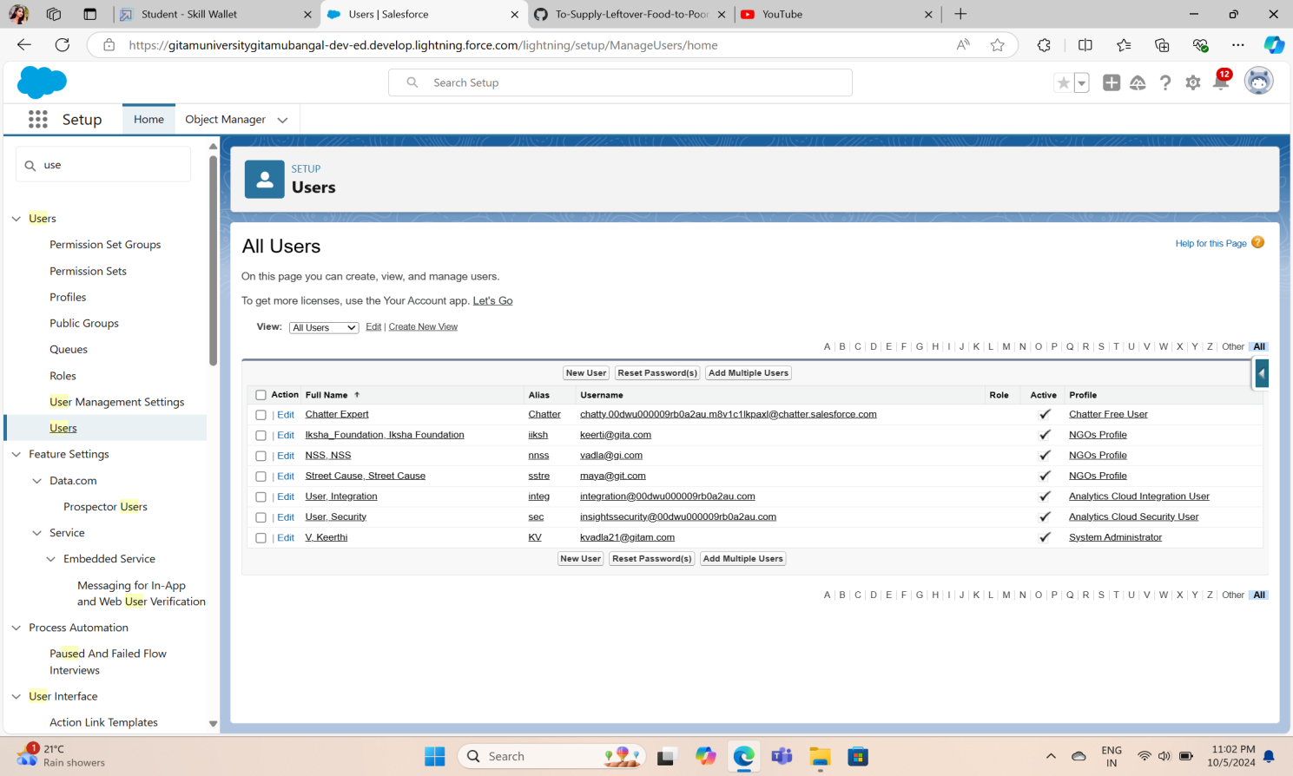

**Public Groups**

Creation of Public Group 1:

Public Group 1 was created for venue managers, allowing them to view and manage venues and drop-off points.

Creation of Public Group 2:

Public Group 2 was created for volunteers, giving them access to tasks and execution details for food collection and distribution.

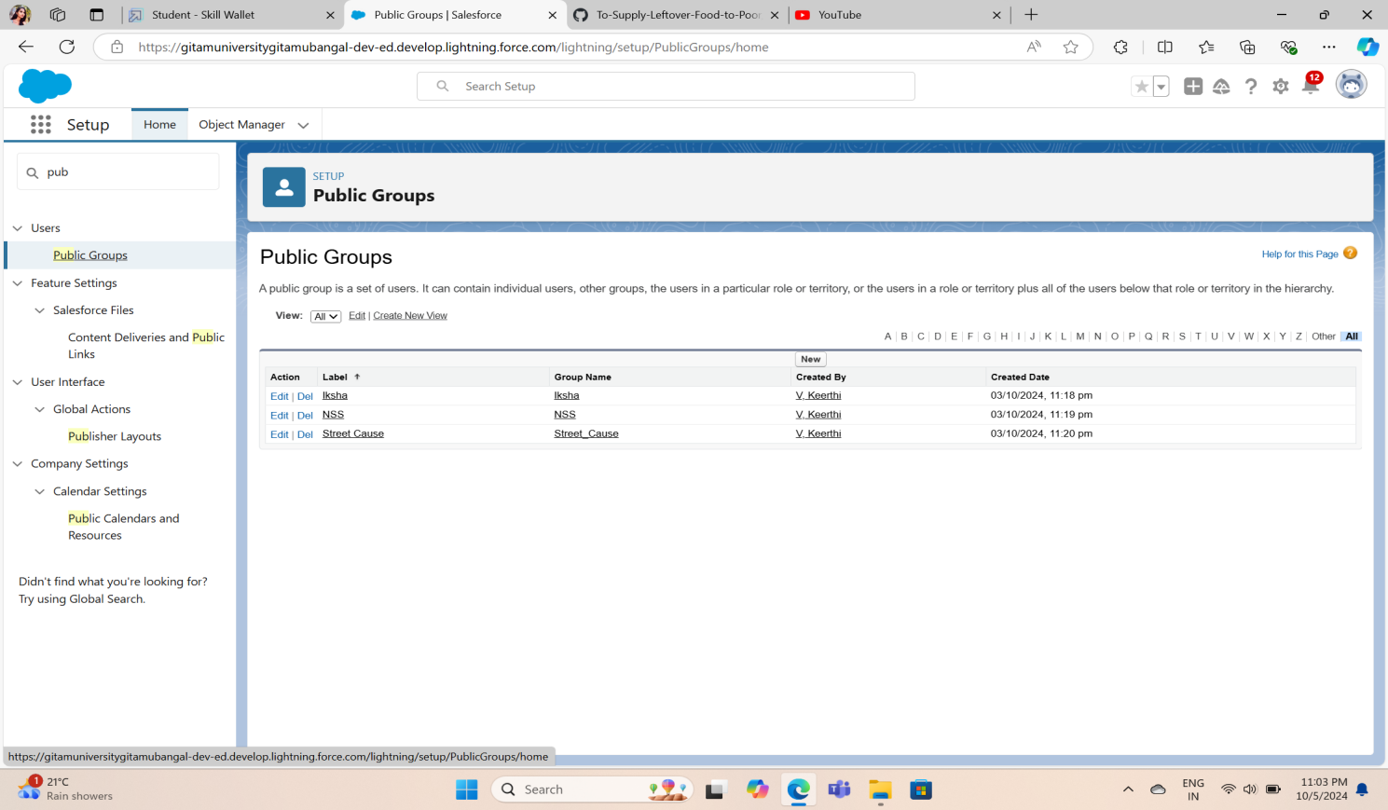

**Report Types**

Creation of Report Types:

Custom report types were defined to allow detailed reporting on venues, volunteers, tasks, and execution details. These report types formed the foundation for creating complex, multi-object reports.

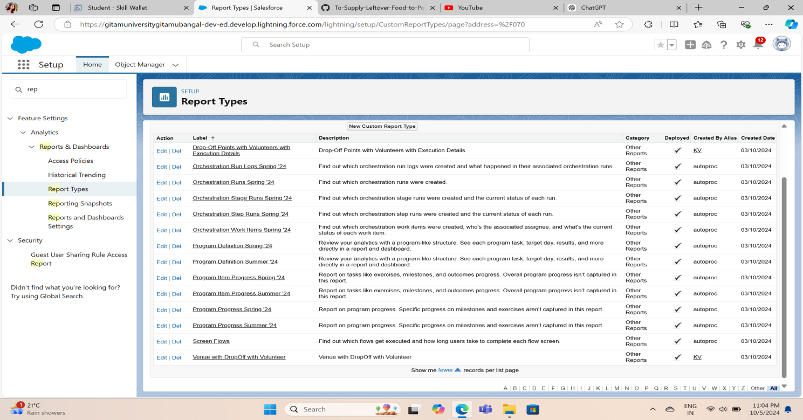

**Reports**

Creation of Report on Venue with Drop-Off and Volunteer:

A comprehensive report was created to show the relationship between venues, drop-off points, and assigned volunteers. This report helps track how much food was collected and distributed.

Creation of Report on Volunteers with Execution Details and Tasks:

This report tracks volunteer performance, detailing the number of tasks completed, food collected, and drop-off points serviced.

**Dashboards**

Adding Venue and Drop-Off Point Report to the Dashboard:

A dashboard widget was created to display real-time data on venue collections and drop-off points, showing total food collected and available storage at drop-off points.

Adding Volunteer Task Report to the Dashboard:

The dashboard also includes a widget tracking volunteer activity, including the number of tasks completed and upcoming assignments.

Adding a Picture to the Dashboard (Optional):

An image representing the project (e.g., a logo or banner for the food supply initiative) was optionally added to the dashboard to provide a personalized touch.

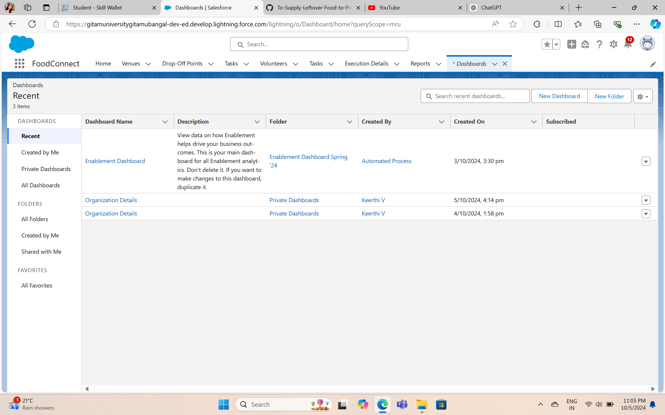

**Sharing Rules**

Creation of Sharing Rules:

Sharing rules were created to ensure that public groups (e.g., volunteers, venue managers) have the appropriate level of access to data while maintaining privacy where necessary.

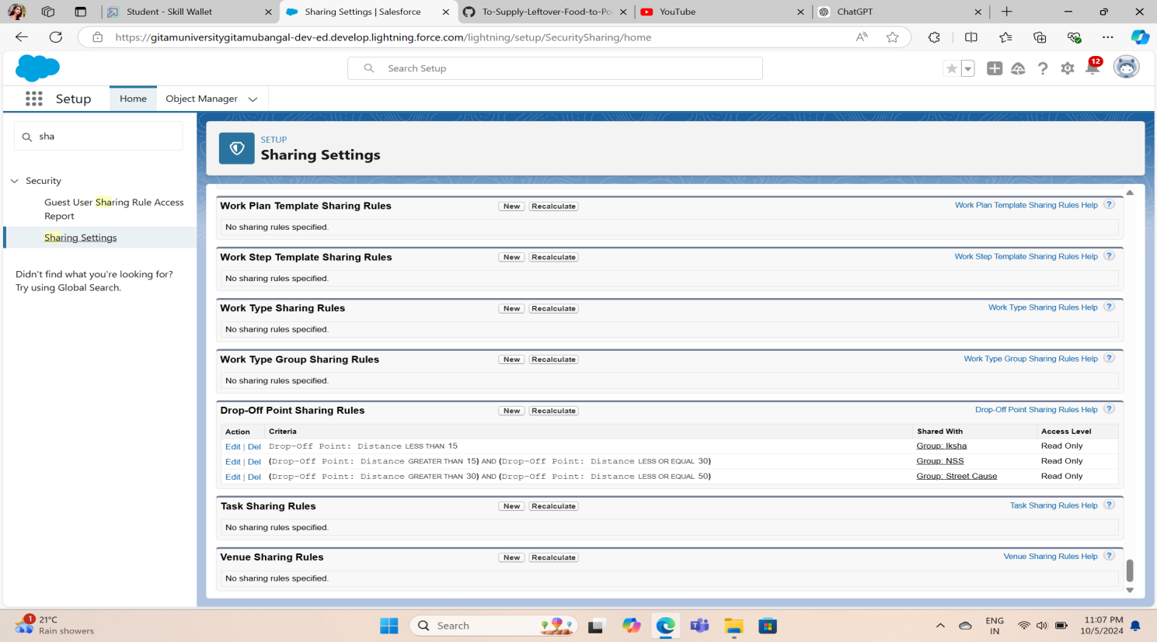

**Home Page**

Creation of Home Page:

A customized home page was developed for users, offering quick links to frequently used objects, reports, and dashboards, improving navigation and user experience.

Conclusion

This Salesforce project successfully created a platform for managing food donations and distribution. It streamlined operations by automating tasks, generating detailed reports, and providing a visual dashboard for real-time monitoring of food supply and volunteer activity. Through custom objects, flows, and reports, the platform maximized efficiency and impact in supplying leftover food to those in need.

